Name:
Block: Date:

Add the following information to the world map. Create your own legends and symbols.
7 | Continents | 5  2 | Bodies of Water | 12 | Rivers | 6  2 | Mountains & Ranges | 18  24 | Countries
18  24 | Capitals | 8  RF | Deserts | 9 | Wonders of the World | 7 | Meridians & Parallels | 5  1 | 5 Indigenous Groups (Regions)
3 | Regions: | Wine, Mining, Oil, Ancient Civilization, etc. /100

 | North America 3 size – 4 population, South America 4-5, Africa 2-2, Europe 6-3, Asia 1-1, Antarctica 5-7, Australia 7-6
 | Pacific…
 | Nile (A), Yangtze (As)…
 | Alps, Mount Everest, Appalachians…
 | (Canada/United States of America/Mexico) (Brazil…
 | (Ottawa/Washington DC/Mexico City) (Brazilia…
 | 9 Wonders
 | Equator, Tropics, Circles, International Date Line, Prime Meridian
 | Indigenous People  (original area/nomadic)  Write-up needed |  | 5 Groups
 |  |  | Focus Group – Pictures and Description
 | Regions |  | Rainforests (2) |  | Deserts (4)
 |  |  | Wine |  | Other
 |  |  | Mining

PART II Line Graph/Bar Graph – for temperature and precipitation. (Favourite place to go or want to travel to)

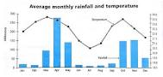
(Need a table of monthly temp and precipitation /10)

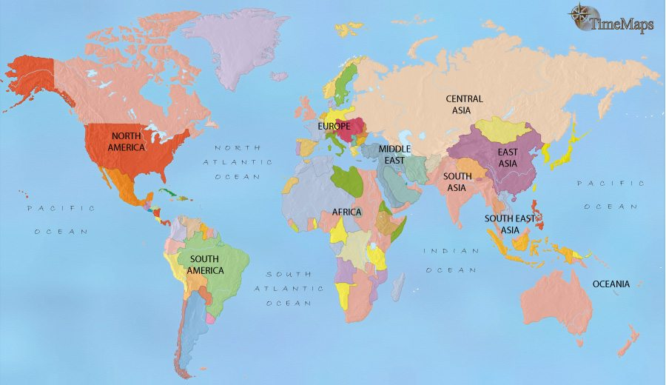
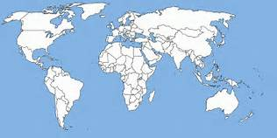

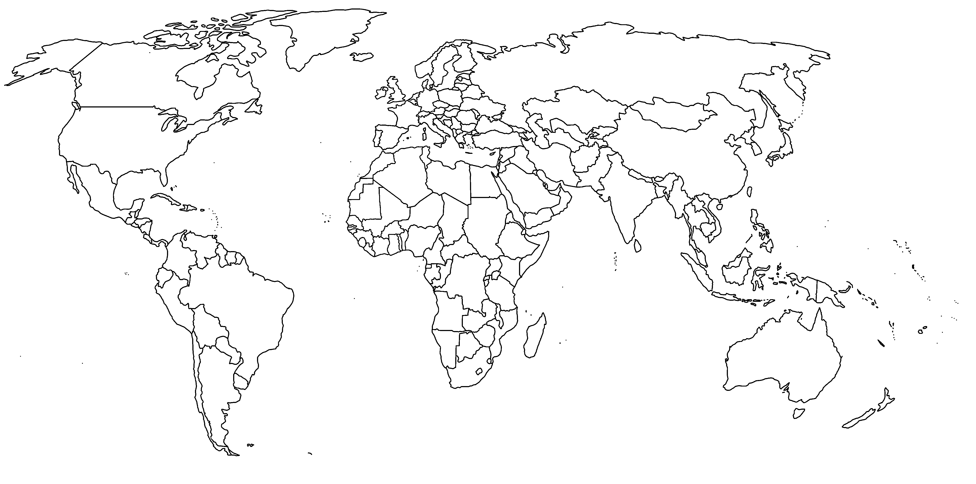

Use above map for rough copy. Please ask the teacher (Mr. Kraus) when you are ready for a large good copy of a World Map.

Part III Pick one of the following. What does it stand for and what does the organization do: (/10) Bonus
NATO
NAFTA
UN
G4
CHRA

