Name:
Block: Date:

Add the following information to the world map. Create your own legends and symbols.
7 | Continents | 7 | Bodies of Water | 12 | Rivers | 6 | Mountains & Ranges | 18 | Countries
18 | Capitals | 5 | Deserts | 9 | Wonders of the World | 7 | Meridians & Parallels | 8 | 5 Indigenous Groups (Regions)
3 | Regions: | Wine, Mining, Oil, Ancient Civilization, etc. /100

 | North America 3-4, South America 4-5, Africa 2-2, Europe 6-3, Asia 1-1, Antarctica 5-7, Australia 7-6
 | Pacific…
 | Nile (A), Yangtze (As)…
 | Alps, Mount Everest
 | (Canada/United States of America/Mexico) (Brazil…
 | (Ottawa/Washington DC/Mexico City) (Brazilia…
 | 9 Wonders
 | Equator, Tropics, Circles, International Date Line, Prime Meridian
Indigenous People
(original area/nomadic)
Write-up needed
 | Regions |  | Rainforests (3)
 |  |  | Wine
 |  |  | Mining

Line Graph/Bar Graph – for temperature and precipitation. (Favourite place to go)

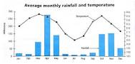
(Need a table of monthly temp and precipitation /10)

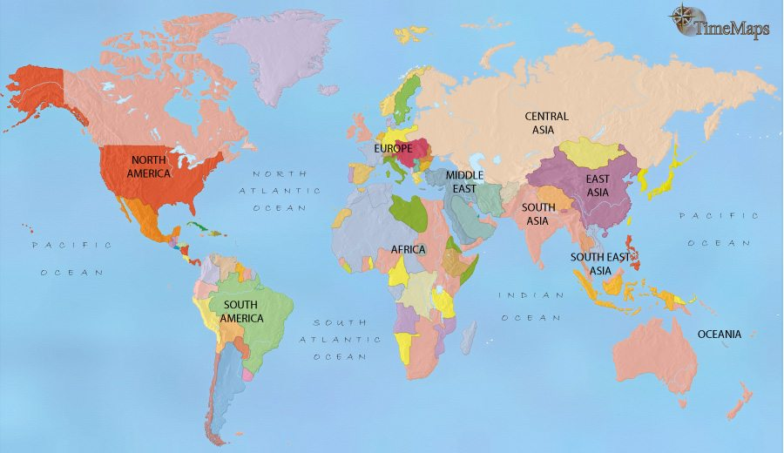
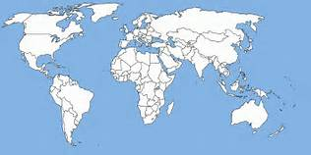

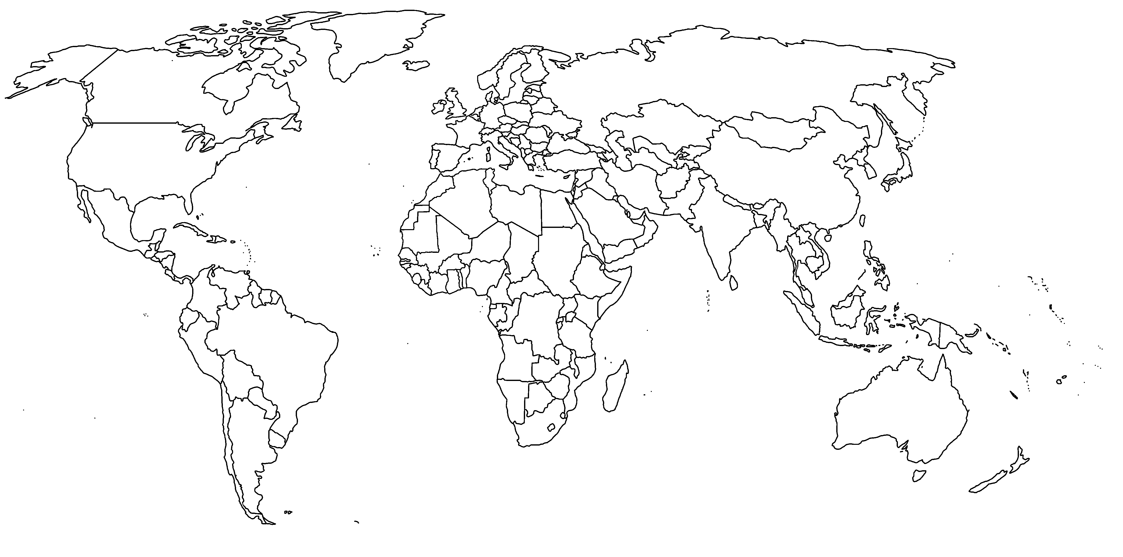

What do the following stand for and what does the organization do: (/10)
NATO
NAFTA
UN
G4
CHRA

