Objectives:
- To connect and identify the traditional 7 teachings presented and understand the connections to each creature.
- To personally reflect on one’s own life and personalize the teachings.
- To understand and appreciate the connection between life and our future.
- To create visual template that connects information
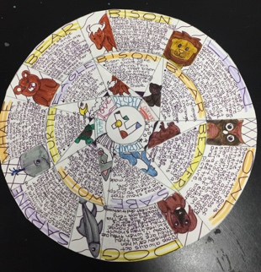
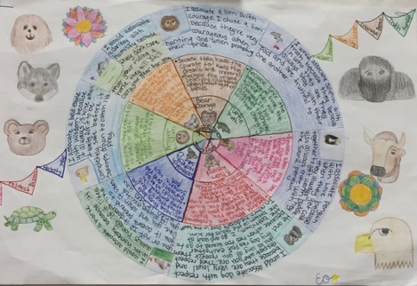
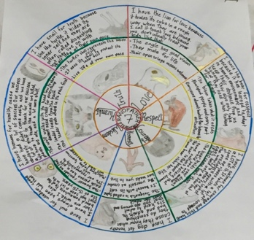

Criteria:
Identify 7 the Teachings
Identify 7 Traditional Creatures - visual
Explain 3 facts (point form ok) of why creature is associated with teaching. Bonus for personal research.
Personal reflection and selection of a Creature of your choice associated with each teaching. Explanation of why. /20
Clarity/Formatting/Design /5

Note: There will be class time provided; lease make sure you are prepared to work with necessary computer, art materials, etc. Some students may have the option to do this assignment digitally and would need to send proposal to teacher.

Assigned Date:
Date Submitted:

