Vancouver Field Trip

Congratulations of being invited to our Fall 2016 Vancouver Field trip. This is should be fun and culminates some of the skills and concepts presented in class. Hopefully you get some practical application to the theory and facts learned.

Name: Block: .

Part 1
Departure meeting place: time .
West Coast Express Experience:

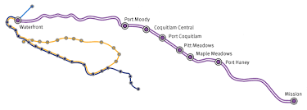
What would you consider the scale of this map to be? Please use the scale symbol.
How would you put the compass rose (North) on tis map?
What would be the distance travelled?

Part 2 Granville Island
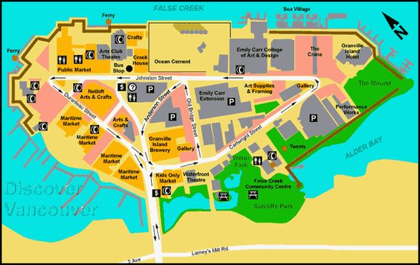

A15

A14

A13

A12

A11

A10

B01 B02 B03 B04 B05 B06 B07 B08 B09
Pick 4 landmarks or points of interest. Take pictures and give a brief description explaining what, why, how, etc. Add Grid location to each
1
2
3
4

Fly Over Canada
At Fly Over Canada you will spend approximately 30 minutes getting introduced to our great country. You will first enter the preshow area where you will be immersed in an audio-visual show of Canada “up close and personal” before heading to the boarding zone for your pre-flight briefing. You will then hit your flight deck and spend eight (8) minutes on the unforgettable Ultimate Flying Ride soaring east to west over some of the most spectacular scenery the country has to offer.

What are the top 3 places you remember from the show and why?

Will you use any of these landmarks or destinations in your virtual tour?
Can you gather information or get pictures to help your project?
Have a great day!

Make sure you have contact numbers

