UNIT: MAPPING Name: . Block: .

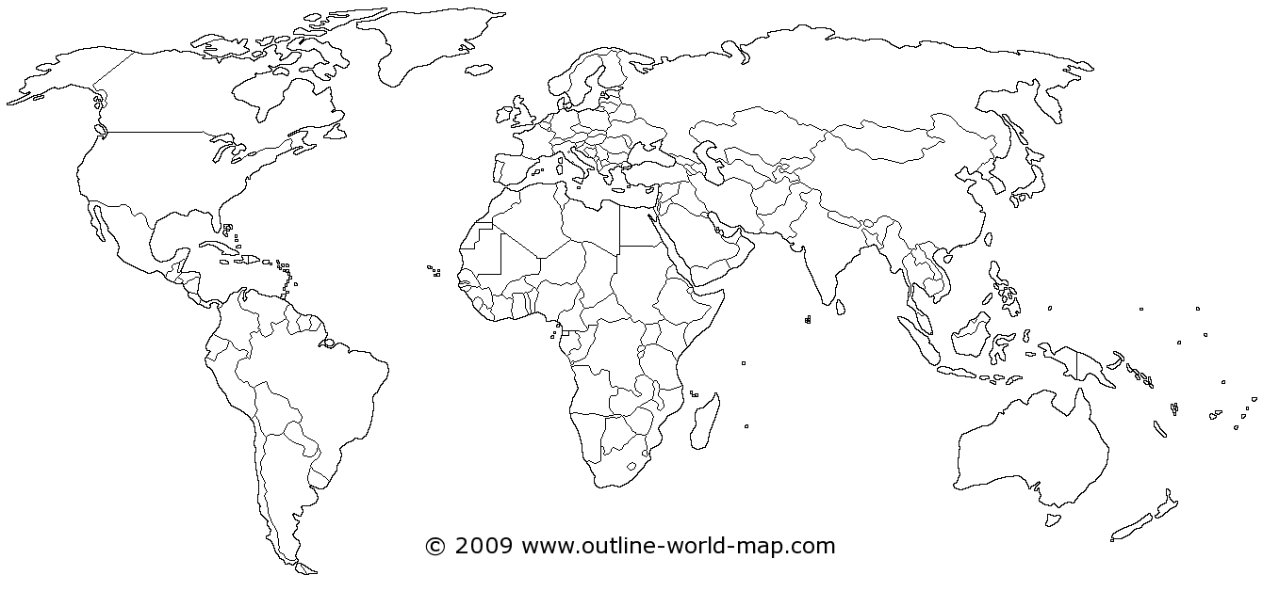
Continents Natural Features
1. | North America | A | Pacific Ocean
2. |  | B | Atlantic Ocean
3. |  | C | Mediterranean Sea
4. |  | D | Arctic Ocean
5. |  | E | Southern Sea/ Antarctic Ocean
6. |  |  |  | F | Canadian Shield
7. |  |  |  | G | Gulf of Mexico
 |  |  |  | H | Indian Ocean

Generic Questions
1. a. Which continent is the largest? b. Which country is largest in size?

2. Which country is the largest by population?

3. a. What is the capital of Canada? b. What is the capital of British Columbia?

4. Identify 3 US Presidents:

5. Identify 3 Canadian Prime Ministers:

6. Identify a Landmark in Vancouver?

7. What lines run from the N Pole to South Pole on a globe – helps with time?

8. What 4 cities lie between Maple Ridge and Vancouver if you go past Coquitlam Center?

