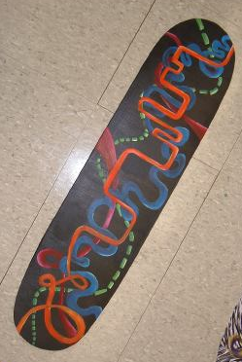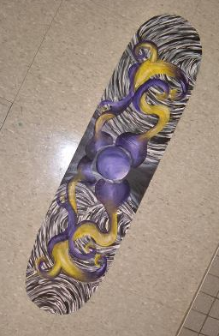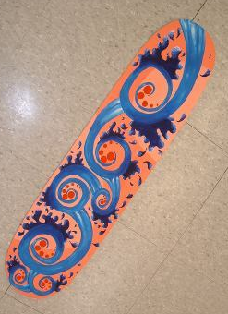

True art is characterized by an irresistible urge in the creative artist.

Final Composition. Elements and design

10

10

1. Students will be able to generate ten ideas using no more than 7 lines to convey action or motion.
2. Students will be able to use the elements of art and principles of design to create a visually appealing unique skateboard deck design.

Objectives:

Skateboard Deck Graphics

Rubric on 2

Assessment:

Effort and In class behavior.

Completion of 10 rectangles and 3 developed

Craftsmanship.

10

10

10

10

Mediums used respectfully

-Albert Einstein

Due Date:

1. Worksheet with 10 rectangles. Draw a different design on each using 7 lines that show motion and action. (thin, thick, wavy, organic, etc.)
2. Take the best 3 out of the 10 and develop them into skateboard designs. Designs can include – Added shapes/ added color/ added lines.
3. Using medium of choice (pencil crayon or oil pastel) create your skateboard deck design.
4. Artwork will be presented when finished.

## Instruction:

+

+

Total: 50 (possible points)

Your Total:

Student comments:

Teacher comments:

Excellent Good Average Needs Improvement

|  |  |  |  |  |
| --- | --- | --- | --- | --- |
| Student completed 10 rectangles exercise and developed 3. | 10-9 | 8-9 | 7-8 | 6-lower |
| Students composition shows understanding of elements and principles of design. | 10-9 | 8-9 | 7-8 | 6-lower |
| Mediums used respectfully. | 10-9 | 8-9 | 7-8 | 6-lower |
| Effort: took time to develop idea and complete project/ Good use of class time. | 10-9 | 8-9 | 7-8 | 6-lower |
| Craftsmanship- Neat, clean & complete. | 10-9 | 8-9 | 7-8 | 6-lower |

Assessment Rubric