ISO is simply a camera setting that will brighten or darken a photo. As you increase your ISO number, your photos will grow progressively brighter. For that reason, ISO can help you capture images in darker environments. However, raising your ISO has consequences - too high of an ISO will show a lot of grain, also known as noise. So, brightening a photo via ISO is always a trade-off. You should only raise your ISO when you are unable to brighten the photo via shutter speed or aperture instead.
Every camera has a different range of ISO values (sometimes called ISO speeds) that you can use. A common set is as follows:
- ISO 100 (low ISO 200 400 800 1600 3200 6400 (high ISO)
When you double your ISO speed, you are doubling the brightness of the photo. So, a photo at ISO 400 will be twice brighter than ISO 200, which will be twice brighter than ISO 100.
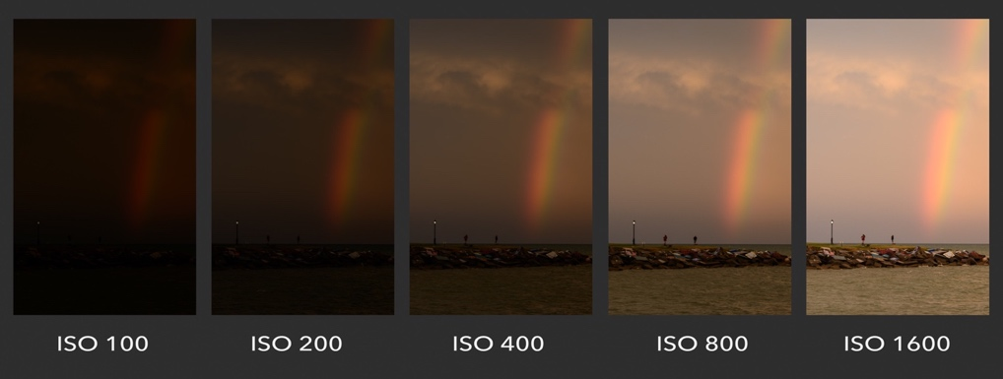
Challenge: Experiment with ISO at different speeds to become familiar with the operations and use of this exposure tool. Try to do it with landscape and you may want to use a tripod to have the same image and lines.
The most common lowest setting, however, is ISO 100, hence the name of this challenge (but don't get too hung up on the number, we probably should have called the challenge "LOW ISO").
Today you can amp up your ISO and shoot in the middle of the night, but the results will not be very clear. When shooting with the lowest ISO, we are ensuring the MINIMUM amount of grain possible, ie - the clearest image. Generally, this should be our first goal when shooting. Only when we are in darker environments, should we adjust to higher numbers accordingly.

Stay in the light for our challenge! You can only shoot at low ISO's when there is a lot of sunlight (or flash-lighting) available! Do yourself a favor and get outside. Still can't get enough light into your camera? Get a tripod and lower that shutter speeeeed.

MOBILE PHONE users - There is a "manual" setting on most phones that will allow you to control ISO. You'll see a big difference right away, so get into the sunlight! You can also download a more advanced camera app that will allow you to manually control these settings.

Assigned Date:
Due Date:

