Shutter speed impacts your images in two key ways:
- It increases and decreases exposure (i.e., image brightness)
- It increases and decreases sharpness (i.e., image detail)

Shutter is one of the three components of the triangle of Exposure. The other two being aperture and ISO.
Shutter speed is exactly what it sounds like: It's the speed at which the shutter of the camera closes. A fast shutter speed creates a shorter exposure — the amount of light the camera takes in — and a slow shutter speed gives the photographer a longer exposure. Shutter speed is responsible for two things: changing the brightness of your photo and creating dramatic effects by either freezing action or blurring motion. In the following article, we will explain everything you need to know about it in very simple language. If you use Auto mode, your camera will select the shutter speed for you, and you will have zero ability to make changes. If you use Manual mode, you can dial in the shutter speed at will (and you can also independently select your aperture and ISO).

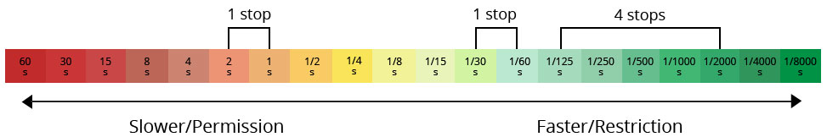
If you use Shutter Priority mode, you can select the shutter speed and the ISO, while your camera will select the aperture for the optimal exposure (based on its evaluation of the scene). If you use Aperture Priority mode, you can select the aperture and ISO, while your camera will select the shutter speed for an optimal exposure (again, based on its evaluation of the scene).
Find two different images. Place 2 pictures of each subject(s) side by side. (Long Shutter and Fast Shutter) | What did you learn?
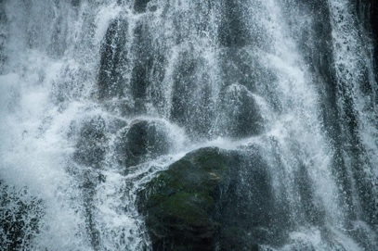  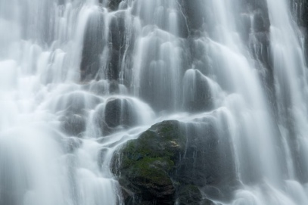  1/500. 4 seconds | 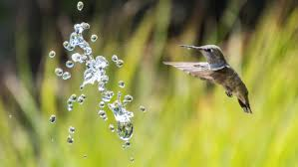  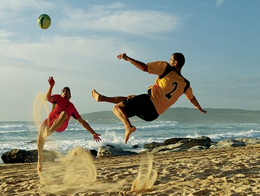  f/5.6, 1/4000 sec)
These pictures were taken with a camera. I chose last subjects ….

