Depth Of Field - is important and often separates those photos that look "amateur" from those that look "professional". Essentially, depth of field is the point or "plane" in the photo-graph that is in focus. Everything BEHIND that point, or IN FRONT of that point will be blurred.
A shallow depth of field (low aperture number, like f/1.4) will have a small sliver of the photo in focus while the rest of the image (in front and behind this sliver) will be blurred or softly focused. On the other hand, a wider depth of field (high aperture number, like f/22), usually seen in architecture or landscapes will have most, if not all, of the view in focus. Depth Of Field doesn't depend on aperture (f-number) alone. These 3 things combined will have an impact on the depth of field:
- The aperture of your camera (f-number setting)
- The distance from the subject to the camera
- The focal length of the lens on your camera.
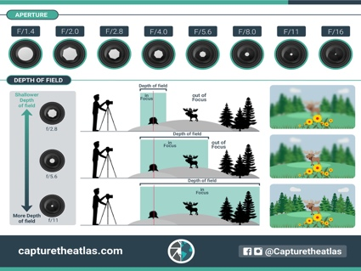
This is another tool you should be using to make your story more powerful! So, find out your story FIRST, and then use these settings to get you there!
Challenge | Find three different images. Place 2 pictures of each subject(s) side by side. (Shallow/Wide) |  | Write a short story for each set of images: what, why, etc.
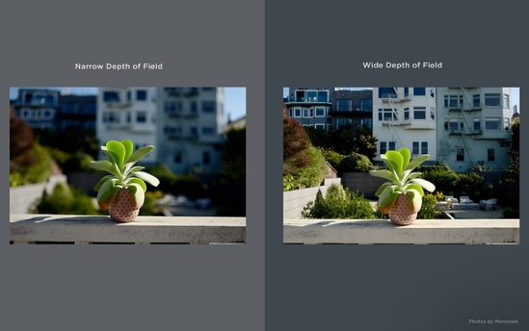 |  | 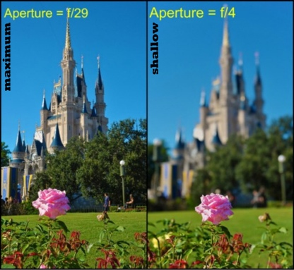 | 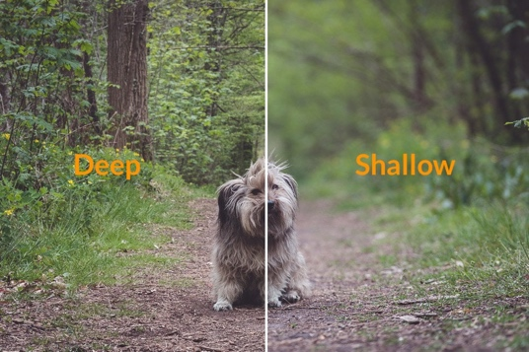
These pictures were taken with a camera. I chose last subject because it is our family pet. I wanted to see if I can bring out more of the dog’s features and which depth of field worked better – shallow versus wide) With a shallow depth of field, only a small portion of it will be sharp. This will help your viewer focus on the most important part of the image. (Weather…)

