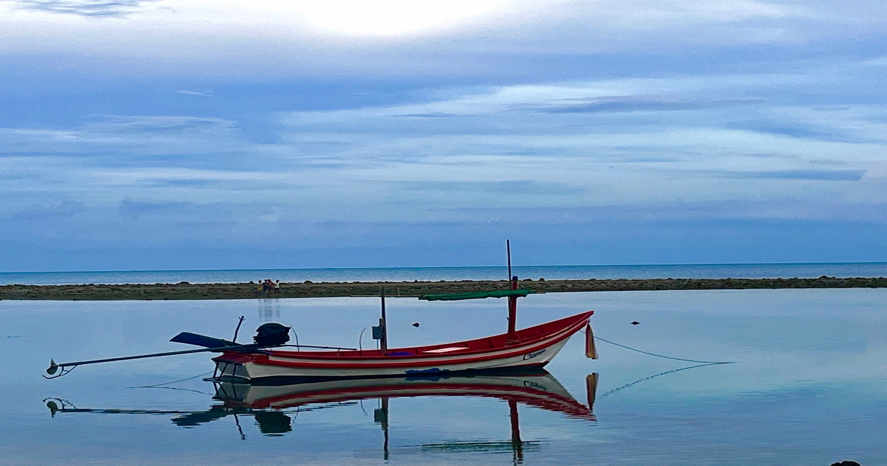
WELCOME TO PHOTO 11 & 12
Maple Ridge Secondary School

What to Expect
Photography 11 and 12 are different courses even though we are in the same classroom. Photo 11 focuses on beginner photography while Photo 12 is more advanced. Both courses are about using a camera to make ART! Through a variety of assignments in this Project-based course, we will explore different techniques to make photos more interesting and artistic…and have some fun along the way. This course will count towards the Digital Art Academy Certification. Curriculum will be adjusted based on students experience and previous work.

What is the Course Content?
This is a project-based course. You will demonstrate nearly all of the learning outcomes by creating projects and submitting them digitally on thumb drive/cloud storage. There are written components to most projects which are an opportunity to explain the intention of the image by self-reflections.

Photo 11 | Photo 12
- The Elements and Principles of Design & Composition  - Learn to use a DSLR camera in manual mode  - Photo Foundations – Exposure, Focus, Lens length  - Controlling Depth of Field  - Manipulating Shutter Speed for desired effects  - Studio Portraiture-studio lighting and natural window lighting  - Macro Photography  - Light Painting  - Adobe Photoshop & Lightroom Workshops  - iPhotography Course Tutorial | - The Elements and Principles of Design & Composition shooting in RAW format  - Theme 1: Identity- family portraits, lifestyle, pet photography, famous photo recreation, flash portraiture  - Theme 2: Time- golden hour/blue hour, night photography, light painting, long exposure photography  - Theme 3: Place- drone, architectural, landscape, street photography, cityscapes  - Theme 4: Story/Documentation- documentary, food photography, product, sports, photo essay  - Theme 5: Creations- abstract, surrealism, HDR, Macro Focus Stacking, tilt shift  - Film Photography & working in the Darkroom  - Adobe Photoshop & Lightroom Workshops

Theme
Each 2-3 weeks will focus on a different topic of photography. The weekly activities are the same every week, with intention to give us a sense of routine, but the topic changes every 2-3 weeks. The activities are meant to be short and informative and take abut 15 min of class time a day. The activities are for completion marks. If you complete the activity thoughtfully and thoroughly you will receive 100%. You should use this in your on-line portfolio.
- Monday/Tuesdays: Photography Modules
- Friday: independent learning/work completion

Photo 12’s will work more independently on the weekly theme having more choice over what themes you wish to study each week. You will submit 1 combined WPS and FPS each week to demonstrate what you learned about your chosen theme for the week. The goal: choose more of what you are interested in, study photographers that you are interested in getting to know more about, continue critiquing professionals work

Workflow
There are 3 main parts to digital photography:
- Understanding and demonstrating technical use of elements of design and operating a DSLR
- Post editing using Adobe Photoshop and Lightroom and various programs
- Sign up and complete a minimum of one Yearbook category

Some of your photos for this course can be taken during class time at school…BUT…I encourage you to sign out cameras and do your shooting as your ‘homework’ and use your in-class time for editing. You will quickly get bored of taking photos at school. You will find more interesting subjects if you use out of school locations/subjects/ideas/lighting at different times of the day, etc.

Photo 12 students are expected to be shooting outside of class time and pre-planning their photoshoots. It is recommended to have a journal and or planner, camera card (64 or higher), one back-up storage device.

Evaluation Major Assignments/Projects 60%
Bi- Weekly Theme Completion Activities 30%
- Photoshop Workshops
- Famous Photographer Studies
- Weekly Photo Study - Modules
Class Participation / Field Trips 10%

Expectations
Students are expected to act in a mature and respectful manner which includes:
- Arrive on time and be prepared for class
- Clean up after yourself. Put all equipment away/Log out of computer and push chairs in or stack at end of the day.
- Assignments handed in online are complete and on time
- Be socially responsible/help others

Materials and Supplies
- All equipment necessary for this course will be provided.
- Hand in your parent/guardian signed Equipment Sign out Permission form so that you can sign out camera gear overnight/weekend/holidays
- Most course information will be posted online, and assignments will be handed in person, by thumb drive, or by e-mail (www.krauster.weebly.com)

Portfolio Sections
Technical – Learning Modules and Assignments
Projects – Personal Gallery
Stop Motion
Videography/ Documentary - Personal
Yearbook Category – submission of best 5-7

Final Note…
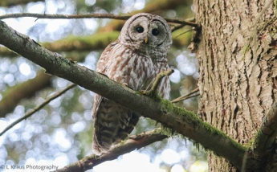 | 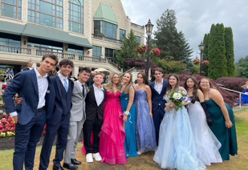 | 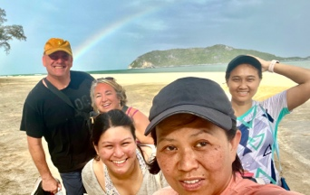 | 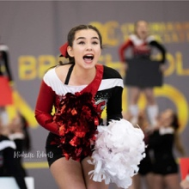 | 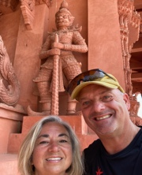
Have FUN!!! I hope you enjoy this year as you learn to create art through photography.

