This is an opportunity for students to explore the values of typography and the lines which fall under the “Principles of Media Art.”
- Make sure to practice and create thumbnails prior to starting your final work on thick paper.
- The time frame should be 2 hours for completion. Over 2 hours of class time will be given.
- Must be complete by and submitted to teacher.

Typography
The art and technique of arranging type to make written language legible, readable, and visually appealing. It involves the selection of typefaces (fonts), their size, spacing, and layout to create printed and digital text. Typography is crucial in various design fields, including media arts, for several reasons:

- Communication: conveying the intended message or information.
- Visual Hierarchy: helps establish a visual hierarchy guiding readers' attention to key elements.
- Branding: use of specific typefaces and styles helps create brand recognition and reinforce a personality.
- Mood and Emotion: evoke various emotions and moods.
- Legibility and Readability ensures that text is easily legible and readable.
- Aesthetics: a critical aspect of design aesthetics - visually pleasing and engaging.
- Consistency: visual consistency ensuring that all text elements have a cohesive style and appearance.
- Accessibility: accessible to a wide range of audiences, including those with visual impairments.
- Cultural and Contextual Significance: can carry cultural or historical connotations.

Lines
Lines and shapes are the foundational elements of visual design, and their understanding is crucial in media arts. They play a significant role in conveying messages, creating visually appealing compositions, and shaping the emotional impact of artworks and media content. Whether in graphic design, animation, film, or other forms of media arts, mastery of lines and shapes is essential for effective communication and creative expression.
Create your own unique name card that is visually appealing from near and far (8m)
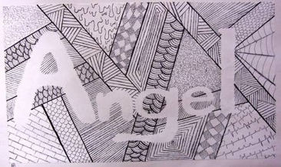
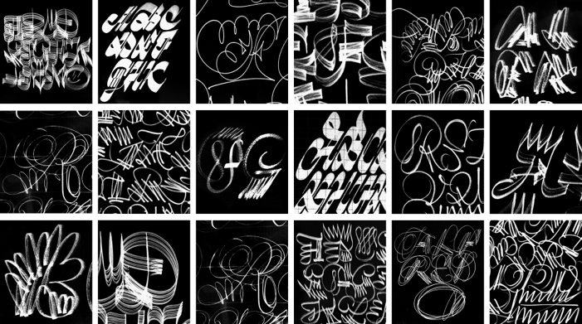
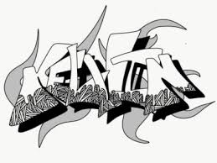

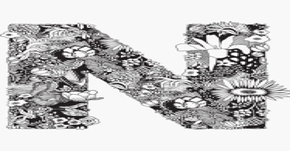

Assigned Date: October 14, 2023
Due Date: On or before November 3, 2023

