This is an opportunity to choose an art project of choice (Artistic Fredom). There are very few
Guidelines apart from:
- Make sure to submit a proposal and have it approved. (Sheet provided)
- The time frame should be 3-4 hours for completion. Over 4 hours of class time will; be given.
- Must be complete by October 27, 2023 and submitted to teacher (75%) with a written description of the art work (25%): process for creating it and the story behind the work.
The idea is to share your interests or skills that you have are have learnt and to create a meaning full art piece. You may need to find certain supplies if not available in the classroom depending on your project of choice.

Make your story more powerful! If you write it out and use programs online to help convey your message stronger – use them.
Create Your Own Vision
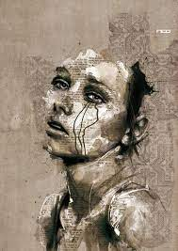
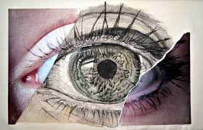
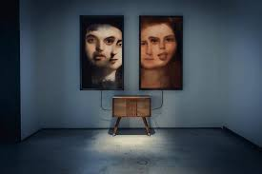

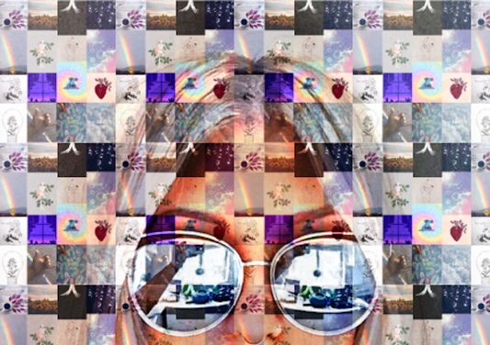

New Media Arts is so diverse and fascinating that you will need to explore for ideas. There is a strong push for computer generated and as we progress, familiarity with Adobe programs, Canva, PowerPoint and others will be key.

Assigned Date: September 14, 2023
Due Date: October 27, 2023

