WELCOME TO MEDIA Arts
11 & 12
Maple Ridge Secondary School
Mr. Lance Kraus Room 1232

What to Expect
It is essentially combining other arts & crafts materials or collage cut outs with your photos to create an artsy composition. There is usually a deeper meaning to the artwork, storytelling, or a great aesthetic quality involved; meaning there are not random placements of elements within the composition to the artist or view. With digital resources and technology’s continual growth, there has been a change with a shift to using images as a base or focal point. In this program we will bet using media and art to create projects that hopefully ourselves and others! Through a variety of assignments in this Project-based course, we will explore different techniques to produce work that is more interesting and artistic; and, have some fun along the way.
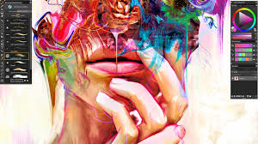

Curricular Competencies Explore and create

Create media art using sensory inspiration, imagination, and inquiry

Examine artistic possibilities and take creative risks, using various sources of inspiration

Refine skills and techniques from various styles and genres

Refine skills and techniques in creating media artworks using a variety of mediums/programs

Demonstrate innovation in creating media artworks and resolving creative challenges
Reason and reflect
Interpret and evaluate how artists use materials, technologies, processes, and environments in media arts
Recognize and evaluate creative choices in the planning, making, interpreting, and analyzing of media artworks
Examine the influences of a variety of contexts on artistic works

Communicate and document
Document, share, and engage with media artworks in a variety of contexts
Demonstrate respect for self, others, and place through art making

Connect and expand
Demonstrate personal and social responsibility associated with creating, perceiving, and responding in media arts
Create artistic works to reflect personal voice, story, and values
Evaluate personal, educational, and professional opportunities in media arts and related fields
Engage in digital citizenship throughout the creative process
Demonstrate safe and responsible use of materials, tools, and work space
What is the Course Content?
This is a primarily a project-based course. You will demonstrate nearly all of the learning outcomes by creating projects and submitting them digitally and eventually putting all your work together as a digital portfolio. There are written components to most projects which are an opportunity to explain the intention of the image by self-reflections.

Media Arts 11 | Media Arts 12
- The Elements and Principles of Design & Composition  - Art Foundations – colour, mediums…  - Rule of Thirds  - Adobe Photoshop & Lightroom Workshops  - Stop Motion  - Typography  - Graphic Design  - Mixed Media | - Media Arts 11 plus,  - The Elements and Principles of Design & Composition  - Story/Documentation- documentary, food photography, product, sports, photo essay  - Promotional Video  - Portfolio
Themes
Each term we will focus on a major project based on an art theme. The bi-weekly activities will give us a sense of routine, but the topic changes. The activities are meant to be short and informative and take abut 15 min of class time a day. The activities are for completion marks. If you complete the activity thoughtfully and thoroughly you will receive 100%. You may use this in your on-line portfolio.
- Friday: Independent Learning/Project Days

Media 11/12 students will have opportunities to work independently and in partners or group. You will submit updates each week to demonstrate what you learned about your chosen project. The goal: choose more of what you are interested in, study media art projects that you are interested in getting to know more about, continue critiquing professionals work

Workflow
There are 5 main sections to Media Arts:
- Using the camera (DSLR/Phone)
- Using Videography – creating a story/storyboarding/ A & B Roll
- Post editing using Adobe Photoshop, Lightroom and other programs
- Use of paint and mixed media and its versatility in design
- Experimenting with varied dry mediums

Most work for this course can be done during class time and at school. BUT, I encourage you to sign out cameras and work on your major term projects outside of class time. You will not always have enough class time for certain projects or the best opportunities. You will find more interesting subjects if you use alternate locations/subjects/ideas, etc.

Evaluation Projects 50%
Assignments - Weekly/Bi-weekly Theme Completion Activities 10%
- Workshops
- Famous Art Studies
- Themes
- Class Participation in Regular Review
Portfolio 25%
Engagement – Participation/Diligence 15%
Expectations
Students are expected to act in a mature and respectful manner which includes:
- Arrive on time and prepared for class
- Clean up after yourself/Put all equipment away/Log out of computer and push chairs in
- Assignments handed in online are complete and on time
- Be socially responsible/help others

Materials and Supplies
- All equipment necessary for this course will be provided: However, a DSLR memory card and External drive are recommended.
- Hand in your parent/guardian signed Equipment Sign out Permission form so that you can sign out camera gear overnight/weekend/holidays
- Course information will be posted online and assignments will be handed in person, by thumb drive, e-mail or put on the class server.

Final Note…
Have FUN!!! I hope you enjoy this year as you learn to create meaningful art through media design.

1. Geo Filter/Sports Card/Wordle/Apps
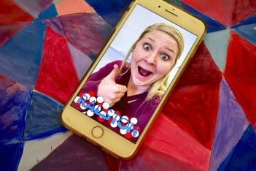
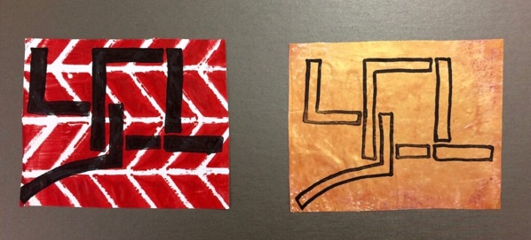
It’s no secret students are enamored with social media. If you’re looking for a project that focuses on design and typography, try creating Geo Filters for your community. Community filters cost nothing to create! You can directly submit your designs to Snapchat for approval. This project is also a great way to introduce Project-Based Learning concepts because your students’ filters will impact the community around them.

2. Personal Logo Designs
Students can then create a personal logo by using an editing program like Photoshop.
Are you looking for detailed information about how to get started with Photoshop in your art room? Be sure to check out the Discovering the Basics of Photoshop Learning Pack! You’ll gain the confidence to introduce basic tools and processes to get your students making art!.
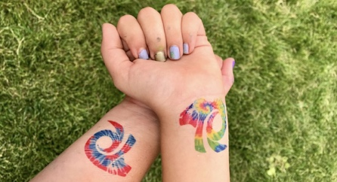

3. Temporary Tattoos. Why not try letting students design their own? Using printable tattoo paper, create digital designs using an inkjet printer. This is a fun way to explore technology, and your students will get to wear their designs!

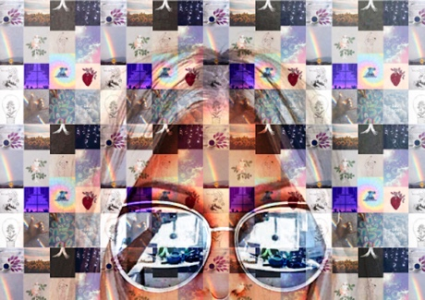
4. Mosaic Portraits
If you use Photoshop, you know there are countless features to the program. It’s always exciting to show your students a new technique. Creating digital mosaic portraits is a great way to put a new spin on the historical process. Follow along with this video to learn how.

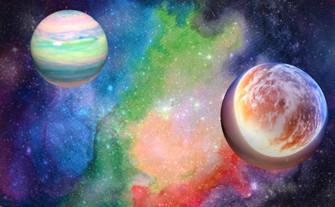
5. Space Galaxies
If you’re looking for a project to explore several new techniques both digitally and traditionally, this is the project for you! Using a medium like watercolor, chalk or oil pastels, students can explore painting or drawing techniques to create galaxy-inspired backgrounds. If you’re looking for instructions, you can check out a step-by-step process for creating a watercolor galaxy in this Learning Pack.
When finished, artworks can be photographed and altered in any digital editing program. Students can even explore 3D editing features to create life-like planets and objects.

6. Animated GIFs
Animating is an engaging process, and there’s no better way to introduce students then by creating GIFs! If you’re looking for a way to get started, check out the animation work by artist Jen Stark. This will inspire your students to create geometric, color changing animations. Use this step-by-step guide to get started.
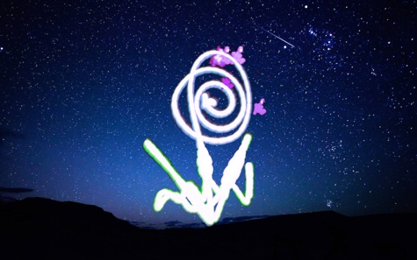

7. Light Paintings
Simply gather up anything that emits light. Glow sticks, laser pointers, phone lights, and Christmas lights work well as light sources. This technique can be done with DSLR cameras using long exposure settings. However, it can also be done on an iPad, smart phone or tablet. Download a long exposure app to create light trailing images. As a bonus, students can digitally edit their photos to create new images.

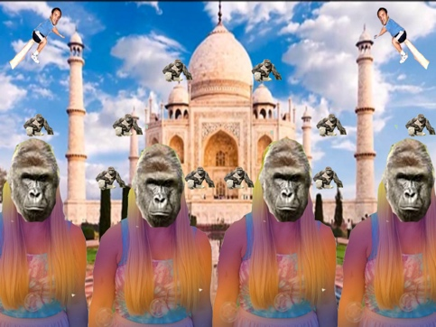
8. Photoshop Your Teacher
Having a sense of humor in the classroom makes the learning environment that much more fun. After my students have learned some basic Photoshop techniques, Give them the chance to show me what they know by altering a picture of the art teacher or a celebrity for practice. This can be a fun process for your students because they have the opportunity create some silly images with your permission. Must stay school appropriate, but you will laugh at your students’ creativity and ideas.

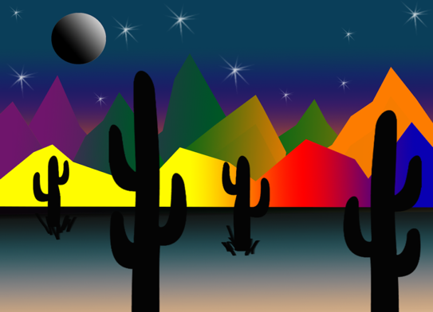
9. Gradient Landscapes
Introduce the gradient tool in Photoshop. Try introducing the gradient tool by creating a landscape image made entirely of gradients. This is an excellent way for students to practice creating foreground, middle ground, and background while practicing the use of the marquee and lasso tools to select defined areas.
Many of these projects go beyond the computer screen and allow students to think creatively and critically. As you introduce your students to the world of technology and art, you’ll start to see the amazing things they can discover.

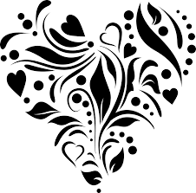
10. Stencil Design

Using Stencils in Mixed Media Art
Including stencils into our mixed media artwork allows us to add a uniqueness to our work without having to worry about creating perfect shapes or drawing the same elements many times over. Stencils make it easy to add shapes and patterns that can be repeated many times across our work. Here we will look at the different types of stencils available and a few of the different techniques you can use them with

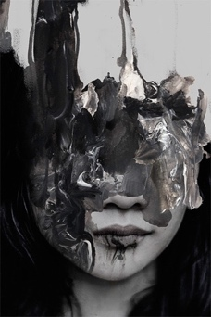
11. Photography and Paint

12. Exposures
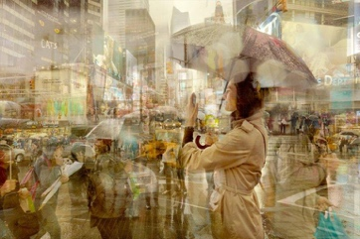

13. Stop Motion Animation

Storyboard / Sound Track

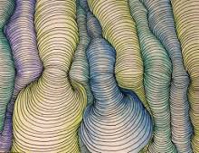
13. Lines
Adobe Illustrator

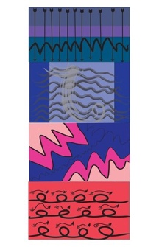

14. Graphic Design – Apparel

15. Self Portrait
Using Photoshop or other program, create a unique self-portrait that may depict personality, mood, etc..

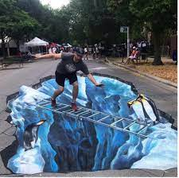
16. Street Art – Chalk Drawing

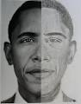
17. Magazine – Portrait – picture/drawing
After creating a thumbnail version (Practice), explore with different dry mediums.

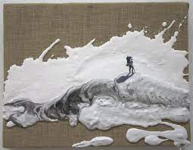
17. Mixed Media on Canvas
In your sketchbook, experiment with patterns and lines. Look at creating a unique texture with paster or related material and then incorporate wet medium and photography.

18. Videography / Documentary
Create a storyboard on a passion of yours or on an individual or topic of interest.
Understand and use A roll and B roll
Experiment with sport, regular, and cinema modes with camera’s phones, and drones
Research and become knowledgeable or an expert on topic
Learn to interview
Learn to use sound effectively
Use photo and video editing tools to complete project
Learn to collaborate with others and create synergy withing group.

