1-2 Understanding and Creating Logos

Important design elements on how ionic logos should be created:
- Describable
- Memorable
- Effective without colour – if use of colour - why
- Scalable i.e. work when just an inch in size
- Relevant to the industry in question

Points one and two go hand-in-hand — if you can’t describe what a logo looks like then how can you accurately remember it? Point three is important because colour is secondary to shape and form. I leave colour to near the end of the design process — if the mark doesn’t work in black only, no amount of colour will rescue the idea. Point four is vital for things like stationery and favicons — those brand items that tend to be smaller in size. Lastly, the design should be relevant for the business it identifies. This is accomplished through in-depth research into the industry in question, and helps to differentiate from closely-associated competitors.

1. Why are Logos Important: research and put into your own words
-You want to be remembered easily -Captures attention
-Separates you from the competition -Easily identifiable
-Inspires brand loyalty -Gives a sense of professionalism
-First impressions are critical -People are drawn to cool looking things
-Creates a sense of community -Defines what/who you are
*-Inspires brand loyalty* -Your story

2. Can you identify one effective logo and one that is ineffective?
Effective | Ineffective
Why?  -The logo is a creative, powerful image. A child enclosed in a world of it’s own with a book tells the shop’s story in a simple yet meaningful way  - Logo is interesting and eye-catching  -Simple and easily remembered while still being far from basic  -Will be powerful in any size  -A logo that could inspire a sense of community among book lovers  -Gives off a great first impression. | Why?  -Not a clear message conveyed  -No story is told except for it’s birth date  -Not eye catching or rememberable, will be easily forgotten  -Picture within logo is confusing, and not easily identifiable  -Won’t inspire much, if any, community spirit  -Firs impression it gives if really bluh!
3. Can you identify these logos and tell me why they are effective?

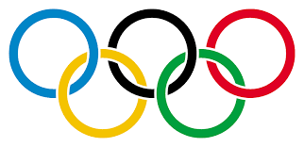 |  | 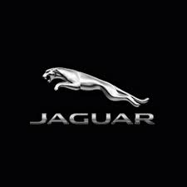 | 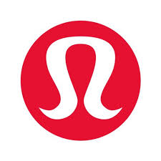
The Olympics  Each ring represents a continent. It was designed in 1912 by Baron Pierre de Coubertin, co-founder of the modern Olympic Games. The colours were selected as they represent every country’s flag that competed. | CBC’s logo was designed to represent them in both English and French. The circle breaking into pieces imitates broadcasting waves. It’s meaningful, tells its story, is a very creative idea and captures attention. CBC is the oldest existing broadcasting network in Canada, established in 1936. | The Jaguar car company’s logo. The leaping jaguar tells the audience of the car’s grace, elegance, and power in one image. A smart animal to use, for the jaguar can run up to 65km/h. Extremely eye-catching and effective to draw people in. The word “jaguar” actually comes from the indigenous word “yaguar”, which means ‘he who kills with one leap.’ | Lululemon’s logo. Is a snazzy A made for a different brand name, “Athletically Hip”, that never went through. However, it’s unintentionally very effective for it appears to be the outline of a woman’s head/hair. As the brand’s core target audience is young women, this is super creative, eye-catching, and memorable. At one point, Lululemon claimed seaweed incorporated into clothing was performance-enhancing. | A leading publisher of games on Console, PC, and Mobile, the Electronic Arts logo is one of the most recognizable gaming ones on the planet. The striking letters and simple yet alluring design is heads and shoulders above the very original one- which was often mistaken for AOE instead because of it’s confusing layout, as well as it was extremely basic. The font used in the current logo was designed specifically for Electronic Arts Media.
 |  |  |  | 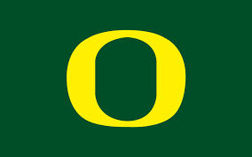
Standing for International Business Machines Corporation, IBM is one of the world’s most famous information and technology companies. It’s been around for over a century, established in 1911, and has gone through multiple logos. The current one was designed in 1972 by Paul Rand. The logo is professional, but still creative with the lines going through the letters. It’s easily recognizable, and now very familiar across the world. As it should be, because IBM is the company who developed the first ever smartphone. Unsurprisingly, they have over 350, 000 employers across the world, but only 30% of them stationed in America. | Founded in 1945, our very own Vancouver Canucks have gone through various logos, but finally seem to be happy with this current one. This logo of their mascot in the shape of a C for Canucks is the most creative and interesting to look at. Which makes people more interested in buying merchandise with it on them. It tells a story of not only the Canucks, but the BC people around them as well. | Instagram’s logo. While phones may have been updated, and the logo as well, the base image of it has not. It depicts an old camera; one that was used in our childhoods, for family photos, etc. This creates nostalgia for the good times and draws in people, making it very effective. Now a daily conversation name, over 40 billion photos have been shared on Instagram. | Spotify’s logo. Started in Sweden in 2006, this logo was made to be simple but eye-catching. The color really pops out at you to capture interest and using sound waves for a music company was clever. It tells you it’s story with very little effort having to be done on your part. Spotify is now the world’s most popular audio streaming subscription. It’s available in nearly 80 countries and contains over 50 million tracks. | The Oregon Ducks are a division one school in America. The O stands for their school/state. While this may not be overly creative, the school is so well-renowned that the logo is incredibly recognizable. Because it’s so simple, it’s easy to be put on nearly anything, spreading the word of Oregon as far as possible. And with that bright yellow pop, it gets incredibly far. Oregon University’s mascot is Donald Duck- making them the only university to have a Disney character as their mascot!

Jade Lenton

