Schum 8
Media Art Indigenous Studies Name:________

Total:___/50 points

Due date: October 30

Ledger Art Project

Objective:
- Explore First Nations unique art forms
- Develop an aesthetic appreciation for Ledger Art
- Understand the complexity and the intricacy of Buffalo Hide/ Ledger Art Paintings
- Understand the historical background of Buffalo Hide/ Ledger Art Paintings
- Research an Indigenous personality and understand their contribution
- Enhance literacy skills by writing a cohesive paragraph
- Connect self to Aboriginal culture

Evaluation:

- Art piece /25 points
- Paragraph/25 points

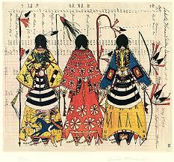

- Art piece:
- Choice and design execution / 10 points
- Choice of colours/contrast/ 10 points
- Neatness/ 5 points
- Paragraph piece:
- Choice of Indigenous symbol/personality / 10 points
- Arguments/explanations /10 points
- Spelling and grammar/5 points

