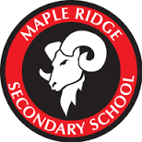
MRSS –School Golf Program/Team

Apparel Order Form
2015 – 2016

Note: All players, as well as parents, have the opportunity to
purchase a team golf shirt. This is great to wear at
local golf courses as well as identifying yourself
and representing MRSS.

The apparel opportunities for this year will be golf shirts and hats. Players are expected to where black shorts, pants, or squirts when training or playing at local ranges and courses. Next year we will have team shorts, light weight jackets, etc.

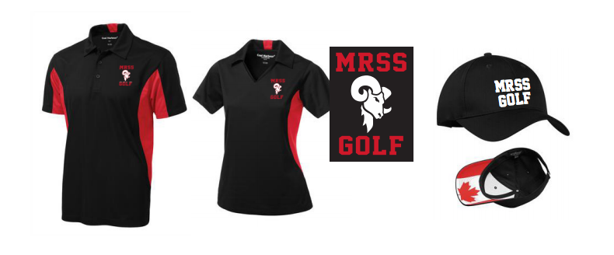

Golf Shirt
Circle: Sex: Girls / Boys
Size: YM / YL / AS / AM / AL / AXL

Number of golf shirts: x 45.00 (tax included)
Total

Name: Phone Number: .
Email: Athlete’s/Player’s Name: .
Date: Grade& School: .
Cash (Payable to MRSS Golf) / Cheque Number ( )

