Introduction: Sports and games is one of many traits that characterizes one’s culture. Historically, these sports and events were very unique to their people but as colonization, globalization, and time passes, they are often lost or changed. Culture can be defined as the characteristics of knowledge and traits of a group of people. Sports is one of many traits that bring people together, create pride, solve resolution and acts as a healing/health tool.
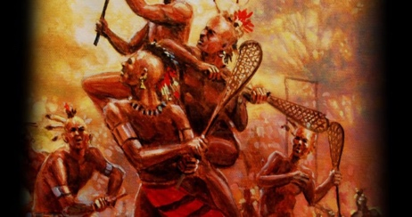
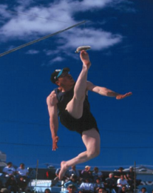
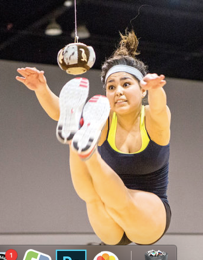
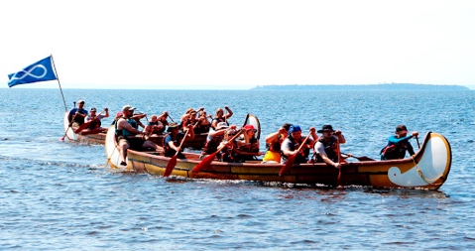

The traditional medicine stickball games, which lacrosse is derived, of the First Nations People are known as the Creator’s Game. These games go back to the very beginning of the oral tradition of nations such as the Haudenosaunee (Iroquois), Sioux, Cherokee, Huron-Wendat, etc. Games sometimes featured thousands of warriors divided into two teams playing on natural fields stretching for 3 miles. It was sometimes called “Little Brother of War” by non-native observers. The truth of the matter is that it is and was a Medicine Game, with an emphasis on healing. A game might be played to heal someone, or perhaps as a peaceful way to determine the rights to hunting grounds, rather than fighting over them. The beginning of change came in the early 1600’s. Europeans began to take notice of this phenomenon. The first ever written mention of the game was in 1637 by Brebeuf, the Jesuit Priest, in Midland, Ontario. By 1867, the year Canada was founded, rules were adopted and a formal sport Governing Body was formed. The reality of a modern Olympic status is certainly only a decade or so away! Although lacrosse has become a modern sport, its root is still medicine and that is what draws millions to play and watch it every year.
https://www.laxfederation.com/lacrosse-history/
The Métis have long enjoyed engaging in contests and sporting events adopted from their First Nations kin, while others were European in origin. In many instances, the contests pitted people against one another in traditional pursuits from the fur trade or from hunting and trapping lifestyles. Traditional events such as horseracing, dogsled racing, flour packing, sack races, running races, egg-on-a-spoon races, and boxing matches were common. While competitive, these events were aimed to bring together people in a region to enjoy the summer and each other’s company. Some of the traditional sports events, which the Métis have participated in include: Canoe racing, lacrosse, double ball and blanket. The Métis played this game by holding a large hide along the edges and tossing a small boy up in the air. The boy was a member of an opposing team and if he cried out while being tossed, the team holding the hide won. If the team holding the hide tired out before the boy cried out, they lost. Men, women and children alike take part in flour packing races, axe throwing, trap setting, starting fires without matches, bannock making, and log sawing. This is great way for people to gain an appreciation of the skills and physical prowess that the Métis needed during the fur trade. The Métis also actively took part in wintertime sporting activities. Some of these activities include skating and hockey, tobogganing, snowball fights, curling, snowmobiling and cross-country skiing. Predating organized hockey, the Métis learned how to skate on frozen ponds and rivers with homemade skates. Today, Métis athletes are involved in all levels of competitive and recreational hockey. Some famous Métis hockey players include Brian Trottier, Theoren Fleury and Reggie Leach. Snow shoe races, too, are popular winter events and are regularly run on January 1.

http://www.metismuseum.ca/media/db/00724
Inuit Alaskan High Kick: To prepare for the kick, athletes sit on the floor and balance on one foot while reaching across the torso to hold the other foot. Leaning back on the opposite hand, athletes thrust the balancing foot straight up to kick a suspended ball, then land on the kicking foot—without losing balance. The ball is raised in increments of four inches after each round. Each athlete is allowed three attempts at each height. When all but three athletes have been eliminated, the ball is raised in one-inch increments until there is a winner.
The Two-foot High Kick is a supreme test of abdominal strength and balance. .Jumping with both feet simultaneously, athletes kick a suspended ball, then land on both feet without falling backwards. The ball is raised in increments of four inches after each round. Each athlete is allowed three attempts at each height. When all but three athletes have been eliminated, the ball is raised in one-inch increments until there is a winner. The Two-Foot High Kick was historically used to communicate the success of a spring hunt.
https://citci.org/partnerships-events/nyo-games/competitive-events/alaskan-high-kick/

Being actively involved in recreational and competitive sports
for much of my life, I find it fascinating that so many traditional
events of the indigenous people have strongly impacted many of
the popular sports today.
The uniqueness of the original First Nations lacrosse game is
extraordinary because it was believed to be a game to peacefully
resolve issues.
The games of the Inuit seem very simple but challenging. It was interesting to see that most activities were individually based and not as a team.
What I appreciated was the correlation between the Metis and my own upbringing. So many traditional activities were incorporated into my youth: sports days, sack races, egg balance and so on.

