Europe’s High Middle Ages

The Story of the Bayeux Tapestry
Introduction
- William the Conqueror victory introduced feudalism and this began the High Middle Ages.
- Feudalism is the ownership of land (manor) in return for protection of the king, such as going to battle. England was broken into huge land sections like counties, kings were assigned to each and castles were built to protect the kings. Barons each were given a smaller section and knights a smaller piece.
- The Battle of Hastings introduced mounted riders as warriors.
- Religion and church controlled lives and determined the wars that would be fought to defend Christianity.

William the Conqueror and the Feudal System
- William the Conqueror came from Normandy and believed that knights required large areas of land to support them
- Removed land from Earls and gave to kings that fought with him during the Battle of Hastings.
- William brutally suppressed opposition within 5 years of introducing
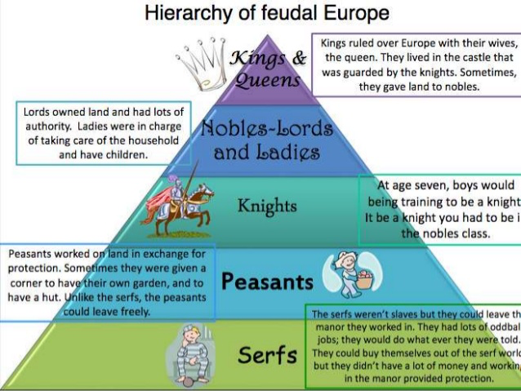
The Feudal Contract
- Fief (land), fealty (loyalty), faith (religion) were the 3 components of the feudal system.
- Land was wealth and given to nobles for loyalty
- Religion bound them to the oath of loyalty and they were committed to supporting the kings army (about 40 days per year)
- Supplied kings with knights when going to war, advise for political issues, money for social engagements such as a son being knighted or daughter being married
- King would defend in return and settle disputes between nobles.
- Oath of allegiance solidified the relationship and this was the Feudal Contract. When people followed the components, peace reigned
- Barons, tenants, and sub-tenants all broke down parcels of land in ever smaller pieces, but barons actually owned a manor
        - Serfs and free holders worked the land. Free holders paid the Baron yearly to own land, serf were considered property
Medieval Life and Custom
The Manor
- Fieths, divided into Manors that had farms, woodlands used either for hunting or as a source of wood, pastures and at least one village, usually found on a water source that provided clean water and power.
- Provided enough food for everyone that lived there including hay and grain for livestock and bread
- Each Manor had its own church, a mill, a blacksmith, a tannery and skilled labour
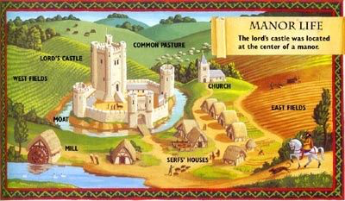
- Demesne was land set aside for the Lord of the Manor to use to make his own profits. Usually gardens, orchards, fields were part of it. The rest of the land was worked by serfs or owned by free holders

- Bailiffs were the managers of the Manor for Barons that didn’t run them themselves.

Ordinary People
- Serfs and freeholders worked most of the land. Serfs were expected to plough, plant, weed and harvest the Baron’s demesne at least 3 days a week.
- Rights were passed down through generations
- Used produce to pay the Lord, then fed the family, then were allowed to sell what was left over for profit
- Serfs were not allowed to leave the property but owned private vegetable and herb gardens as well as a couple of farm animals whose manure would be used as fertilizer. Serfs had a huge calorie requirement because of all the hard work – ate mainly breads, fish, vegetables and drank beer and milk
- Freeholders owned their land, didn’t work for the Lords and were allowed to leave their property

Village Homes
- All the tradespeople and land workers lived in a village. Buildings were built from wood, roofs were thatched with a hole for letting smoke out from an insider fire pit, floors were packed dirt. Houses were very small although 5-6 people shared a single rooms
- Conditions were very unclean and there were many types of pests such as rats, mice, lice, fleas and bedbugs
- No such thing as plumbing or electricity, furniture was scarce and frequently homemade, and beds were usually made from straw

Work and Cooperation
- Everyone worked hard from sunrise to sunset, babies went to fields with their moms and children learned how to farm at an early age
- Serfs and freeholders did not go to school
- Women did everything that was required to keep the house running, such as cooking and baking, cleaning, preserving, weaving and making clothes, childcare, gathering wood, hay, corn for feeding the animals, nuts, berries and herbs for cooking and cures and tending the private garden
- Grandparents were infrequent as people didn’t live very long
- Men farmed; ploughing, planting, weeding, harvesting. Serfs worked both their own and Baron’s land making their work days even longer.

Lord and Lady of the Manor

The Manor House
- Lords and Ladies had many servants and a large house that was attended to by others
- Tapestries on walls helped keep the cold out
- They owned expensive items such as ornate furniture, books and had floors carpeted with rushes
- No plumbing, heating
- Privacy was non-existent inside the Manors as servants slept close and were always near
The privileges
- Expensive items were kept as status symbols including items such as falcons, horses, furniture, and the big houses and they had time for relaxation such as hunting or listening to troubadours
The obligations
- Lords still had obligations to his King.
- Lords could lose their Manor if didn’t meet his obligations such as marrying and having children.
- Arranged marriages were an opportunity for the Lord’s parents to merge with other land owners to increase land and power.

A Woman’s rights

- Boys had rights, girls did not.
- Girls were controlled by their father than husband. Woman with property were considered a prize for a man and were often chased by many. A father would rather marry off his daughter than lose the property.
- If a woman lost her Lord father and became an orphan, the King decided who she would marry.
- Widows kept their property and freedom even if they didn’t remarry and many refused.

Belief and devotion
- Church and Christianity were important in medieval life – people judged after death, and believed in heaven and hell. Religious ceremonies were significant.
- Environmental hardships and problems were punishment for sins.
- Everyday had a saint attached to it. God’s plan determined their place in society. Monasteries and hermits existed because of belief the religion was the ultimate service.

The Church
- Catholicism was the only Christian religion in Europe so was very powerful.
- Excommunication was thought to determine that someone would go to hell as they could not carry out ceremonies and people were fearful.
- Church also dictated monarchs’ behaviours so was as powerful as the Kings.
- Each village had at least one church and one priest and performed marriage, burials, agreements
- Churches collected about 1/10th of income as a tithe but also usually owned their own land so became rich as well as powerful.
- Working for the church and devoting oneself to God was an inviting career as people could improve their social standing

Monastic Life
- Monks had monasteries and nuns lived in convents/nunneries. Everyone took vows of poverty, chastity, obedience and had to prey throughout the entire day. Some people also took a vow of silence and could only speak in prayer.
- There was free time to study, pray, work and copy books

The Law
- Some Canadian Laws came from medieval times such as oaths and prosecutors but many laws are no longer used.

Trial by Ordeal and Trial by Battle
- Trial by Ordeal was the belief that God would protect the innocent, no matter what they were asked to do.
- Trial by Battle was placing the two people arguing into a battle because it was believed that God would not allow the innocent person to lose – was for noblemen but they were also allowed to pick someone to fight

Manor Courts
- Major crimes went to Royal Courts; Church problems went to church courts; Manor courts were for petty crimes, usually farming and property crimes such as ploughing outside their boundaries, assault and petty theft. Like a village meeting but witnesses called and villagers decided who was right and the Baron’s Steward acted like the judge and determined the fine.

Royal Courts
- Major/serious crimes such as treason, murder, burglary, and stealing from the Royal Forest.
- They used Common Law – and declared executions. In 1300 the theft of anything worth more than one week’s wages was punishable by death and all property was taken back.

Church Courts
- Pope had authority over all religious leaders and could judge them. Could not sentence clergy to death and if you could read and write, you were considered working for the church and therefore should be tried in a church court. There was an underground for illegal education so that bad people could convince the courts to try them in church courts.

Henry II and the Murder Thomas Becket
- Pope had control over the monarchy if church. Issues occurred if it wasn’t clear if the problem was church related or otherwise.
- In 1164, King Henry II wanted all clergy that did something bad handed over to Royal courts as thought church courts too soft on the crimes
- Thomas Becket the Archbishop of Canterbury refused so King Henry took his property and chased him to France.
- King Henry allowed him to return six years later but they again disagreed and King Henry publically asked if no one would rid him of this man.
- On December 29, 1170, Thomas Beckett was murdered by 4 knights at the altar at Canterbury Cathedral
- King Henry was forced by Pope Alexander the third to a public flogging at Thomas’ shrine and was demanded to stop interfering with church business
- Two years later Thomas became a Saint and Canterbury Cathedral became one of Christianity’s greatest shrines

World Views

Medieval Geography
- Most commoners were uneducated and didn’t travel outside their close proximity.
- Travellers such as traders and emperors carried weapons to protect against outlaws and travel only occurred in the day time.
- Nobles visiting relatives or going to war learned about other areas but didn’t really know about areas outside of their travels.
- Maps were rare but the ones that existed had Jerusalem at the centre

Contacts with Asia
- Western Europe was affected by things that occurred in Asia
- In the 13th century, Chinggis Khan conquered most of Asia (including China) but allowed Europeans to travel along trade routes all the way to China
- In 1255 Nicolo and Maffeo Polo completed travel to China along the Silk Road was the first time Europeans had made it to China and returned in 1271 with Marco (Nicolo’s son). Khubilai Khan liked Marco Polo so made him an official in his Chinese court and Marco stayed for 17 years before returning. His story influenced European’s knowledge of the world outside of Europe.
- The Silk Road was closed a few years after Marco’s return

The Crusades

- Christian war with Muslims over the ownership of the holy land – sacred places and pilgrimage sites around Israel (where Jesus lived and died) owned by the Seljuk Turks (Muslims) as well as wanting the religious artifacts, properties and valuables that came with the sites.
- Muslims believed that Muhammad rose from Jerusalem and therefore refused to allow it to be given up.
- The crusades were considered so honorable to fight for your God that it guaranteed a place in heaven.
- Altogether there were seven crusades between 1096 and 1254.

Disasters and Victories
- People’s crusades were lead by Walt the Penniless and Peter the Hermit and battles occurred all over Europe. They carried out massacres of Jews and other Christians. Turkish army wipes out these crusades in Asia
- In the 13th century a children’s crusade failed as they were sold to a Arab slave trader
- Armed knights were taken seriously – crusades created a Christian kingdom that lasted for about 100 years until 1187 but the Muslim Saladin recaptured Jerusalem and with lack of direction of the crusaders brought an end to the crusades.

Long Term Consequences
- Crusades taught people more about the Muslim world and exchanged knowledge in medicine, astronomy, philosophy, mathematics and literature which directly lead to the Renaissance period.
- Crusades sparked trade, increased variety of products (silk, worms, fruit, spices) and increased the desire for foreign goods leading to additional trade routes being created and improved economy and standard of living

Royal Power and Democracy

- Monarchy was a part of God’s plan and democracy did not exist.

The Balance of Power
- Monarchy could change laws, change taxes, leaders and property ownership but had to follow the Feudal Code. The Barons either agree with their King or would band and attack.
- Royal Army took time to get support from knights that lived far away. Rebellions were difficult to suppress quickly so the Kings tried to keep Barons happy by following the Feudal Code

Eleanor of Aquitaine
- Eleanor lived 82 years and was the Queen of France and England during that time.
- Louis VII – first husband and had two sons that became Kings of England. Louis ended the marriage because he was impatient with her beliefs
- Eleanor then married Henry II and had 10 children.
- She encouraged them to rebel against Henry and spent 16 years in prison because of her treasonous attempts have her sons murder her husband.
- After Henry died, Eleanor lead England with the support of her son Richard the Lionhearted.
- When Richard died she helped another son King John I defeated enemies in England and France.
- She believed in gender equality and went on a Crusade to Jerusalem but dressed as a man.

King John
- King John I of England argued Pope Innocent III about who should appoint the new Archbishop of Canterbury and was excommunicated along with all of England under interdict (banned all church services).
- Caused commoners to rise up against King John
- Imprisoned Barons’ without court and took their property, took Baron’s relatives and tortured them and raised taxes and forced knights to fight his own people
- The Pope encourage King of France Philip Augustus to invade England so John decided to give England to the Pope as Peter’s Pence – and John forced everyone to pay the taxes

The magna carta
- 1214 John was so hated that the Barons, the church and commoners rose up against him – On June 15, 1215 at Runnymede, John was forced to sign and seal the Magna Carta in which he agreed to respect the rights of his people which included; no punishment (arrest or prison) without trials and no tax changes without Parliament consent – the beginning of democracy.

