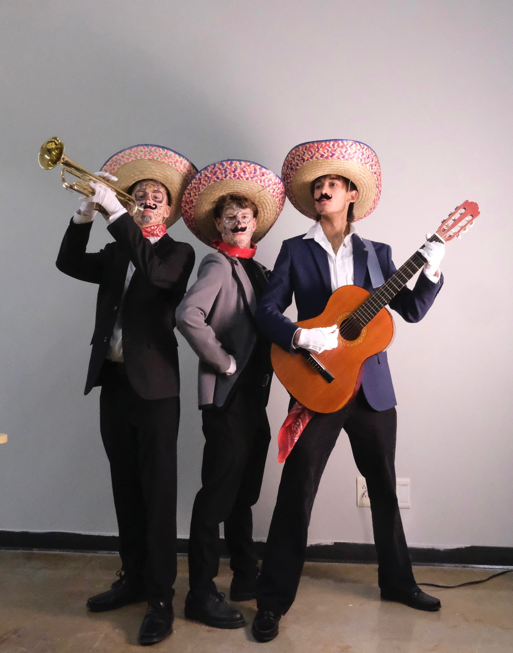

The exposure triangle is a fundamental in photography that involves three key elements: **aperture**, **shutter** **speed**, and **ISO**. Understanding the exposure triangle is crucial because it directly influences the quality and characteristics of the images they capture.

**Here's why it's important:**

**1. Proper Exposure:** The exposure triangle helps photographers achieve the correct exposure for their images. Proper exposure ensures that the image is neither too dark (underexposed) nor too bright (overexposed). A well-exposed photograph conveys the intended mood and details, making it visually appealing.

**2. Creative Control**: Aperture affects depth of field, shutter speed controls motion blur, and ISO influences image noise. By understanding these elements, photographers can creatively control the visual aspects of their photos.

**3. Low-Light Performance**: In challenging lighting conditions, such as low light or indoor settings, understanding the exposure triangle becomes even more critical. Knowing how to adjust aperture, shutter speed, and ISO allows for well-exposed images without compromising image quality.

**4. Technical Proficiency**: A solid grasp of the exposure triangle demonstrates technical proficiency in photography. This knowledge is essential for photographers to confidently use their cameras and make informed decisions in various shooting scenarios.

**5. Problem Solving**: In certain situations, photographers may need to prioritize one element of the exposure triangle over another. For example, when shooting fast action in low light, a photographer might need to compromise on aperture or accept higher ISO to maintain a sufficiently fast shutter speed.

**6. Consistency**: Understanding the exposure triangle enables photographers to maintain a consistent style and look across their body of work.

In summary, the exposure triangle is the foundation of photography, providing the tools to control the technical aspects of their images and allowing for creative expression.

Challenge: this is an assessment of what you have learned in the first 3 challenges and your ability to use the camera effectively. You may do this by yourself or with a friend in class. You have complete freedom to choose the program you will use to present your assessment so you will need to include titles that indicate what section the photos are from.

Have fun with this project as it is varied and gives you a great deal of freedom to be creative. Pictures from activities #3 - #5 can be edited on Adobe Lightroom, Photoshop, or iPhoto. All pictures should be done in **Manual mode** and please record the setting on the pics you use for the project. All pics should be saved as jpeg when finished.

**Possible programs you can use:** Power Point, Google Slides, Canva, Word

|  |  |  |  |
| --- | --- | --- | --- |
|  |  | Points | |
| **Activity 1** | **Texture** | **10** | |
| submit 1-2 pictures of each of the following types of texture: Rough, smooth, hard, soft, organic, and artificial. | | | |
|  |  |  | |
| **Activity 2** | **Aperture** | **20** | |
| **Submit 1 -2 photos of each of the following:**   1. Portrait – head shot 2. Photo 1: high/deep depth of field 3. Photo 2: low/shallow depth of field 4. Create a unique photo shoot and submit the following photos: 5. Photo 1: blur front with a clear subject 6. Photo 2: a clear subject with a blur background 7. Photo 3: a blur foreground, a clear subject, and a blurred background | | | |
|  |  |  | |
| **Activity 3** | **Shutter Speed** | **40** | |
| **Pick 10 of the following and submit 1-2 of each – Some may require you to use the panning technique!**   1. Picture of a pet - stationary (portrait) and one in motion (action). 2. Picture of an organized MRSS sport in motion: wrestling or basketball... 3. Picture of a water source – one with high and one with low shutter. 4. Picture of a vehicle in motion - one with high and one with low shutter. 5. Picture of winter theme: ski, snowboarding, sledding… 6. Picture of sunset or sunrise at a scenic location. 7. Picture of Christmas lights and or a decorated yard. 8. Picture of the Christmas Train – Monday Dec 16th – Port Haney. 9. Picture of RAMBO! 10. Take a picture of a something turning such as an umbrella where your subject is clear but the instrument is burred. 11. Take pictures of Fireworks – New Year’s Eve (ISO). 12. Do a self-portrait using a tripod and setting the camera on a timer. 13. Any movement shot while panning to create a blur background. | | | |
|  |  |  | |
| **Activity 4** | **Creative Photo Edit** | **10** | |
| Take a picture of a family member or friend – with permission – and creatively edit on Photoshop, adding texture and writing. | | | |
|  |  |  | |
| **Activity 5** | **Digital Word Art** | **10** | |
| In Adobe Photoshop, create a memory piece with images and pictures that enrapture Term 1. You may use any picture that is not copyright – yours or others. | | | |
|  | | | |
| **Organization of material in your chosen program** | | | **10** |

**Due: Wed,**

**Jan. 31rst**