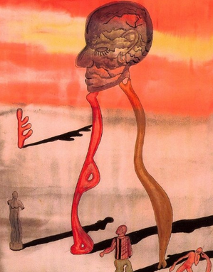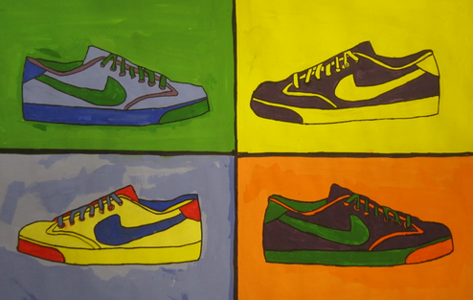

1. **Select an artist from the following list: Frida Kahlo, Georgia O’ Keeffe, Andy Warhol, Leonardo da Vinci, Henri Matisse, Pablo Picasso, Salvador Dali and Roy Lichtenstein.**
2. **Research artist of choice and write a short biography. Biography should include: Basic information on artist, style of artwork, time period, why the artist is important.**
3. **Select a medium that works best for you and suits the artist of choice style. (oil pastel or pencil crayon)**
4. **Create a unique image inspired by your artist of choice, working in the style of the artist.**
5. **When completed artwork will be presented to the class.**

Assignment

### Analyze a variety of image development techniques and design strategies as used by a variety of artists for a variety of purposes.

### Identify tools and equipment used to create images.

### Analyze how individual visual elements and principles of art & design are used to create meaning in images.

Art History Research Project

Total: 50 (possible points)

Your Total:

Student comments:

Teacher comments:

Excellent Good Average Needs Improvement

|  |  |  |  |  |
| --- | --- | --- | --- | --- |
| Students composition shows relationship to original work/  Artist Biography is thoughtfully completed. | 10-9 | 8-9 | 7-8 | 6-lower |
| Students composition shows understanding of elements and principles of design. | 10-9 | 8-9 | 7-8 | 6-lower |
| Mediums used relfects the style of the artist and used respectfully. | 10-9 | 8-9 | 7-8 | 6-lower |
| Effort: took time to develop idea and complete project/ Good use of class time. | 10-9 | 8-9 | 7-8 | 6-lower |
| Craftsmanship- Neat, clean & complete. | 10-9 | 8-9 | 7-8 | 6-lower |

Assessment Rubric