Overview: The medieval manor was an agricultural estate. It was usually comprised of tracts of agricultural land, a village whose inhabitants worked that land, and a manor house where the lord who owned or controlled the estate lived. Manors might also have woods, orchards, gardens, and lakes or ponds where fish could be found.

Objectives: Create/draw your own manor and use a legend to explain the main features of the manor. Be creative and have fun, as this is your own manor and can be designed any way you wish. Include: manor, church, well, river mill, tannery, 3 field system, livestock, orchard and blacksmith. One interesting fact is that most Manors were designed to be self-sufficient. How does this relate to today?

Part 1. Use some the mapping skills learned in term 1: title, border, direction,…
Features | Description
Manor - building | Medieval manor houses were owned by Medieval England’s wealthy – those who were at or near the top of the feudal system. Few original Medieval manor houses still exist as many manor houses were built onto over the next centuries.
Houses | Medieval peasants lived in wattle and daub huts. The poverty of such dwellings was a sign as to where these people were on the social scale and their standing in the feudal system.
Mill | Usually located near the river so it can be used as a power source. Takes the grains from the field and produces flour for baking and various foods
Tannery | This building was important mainly used from 1500-1640. Tanning was the process of making leather from animal skins: shoes belts, gloves harnesses, armour, and bottles. It was a viable and profitable business.
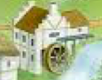
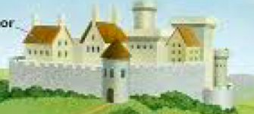
The Medieval Manor

60

59

58

57

56

55

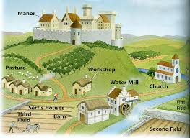
N
11 12 13 14 15 16 17 18

