Overview: Short story elements help describe, explain, and identify key parts of a story. They can be used on any plot
line. The goal is to select a novel (fiction) or a movie that you enjoy and use the plot line to show you
understand the elements presented in class: exposition, inciting incident (problem), rising action, climax, falling action, resolution, and denouement. These elements can be further broken down to include terms such as antagonist, protagonist, supporting, setting, mood, dynamic, static…

Criteria 1. Have a diagram of your choice that represents the story line and the elements in
chronological order – plot line?
2. Have a legend that explains what each element is and how it can be explained
3. Have a diagram that shows your understanding of the elements based on using evidence from
the story you chose. Remember to use statement, evidence and support framework.

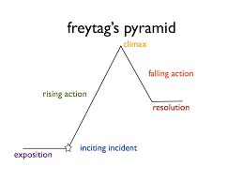
Direct quotes from text or dialogue are recommended. If unsure of how to reference these, please see the teacher.
Element | Description - Definition
Exposition | A literary device used to introduce background information about events, setting, characters, mood, etc.  When talking about characters, key words should pop up: protagonist, antagonist, and supporting. Furthermore, they can be described as dynamic / round or static / flat.  In the setting we try to answer where and when the story or event occurs.  Finally, we need to be able to identify the feeling or the narrative. This is known as the mood.

