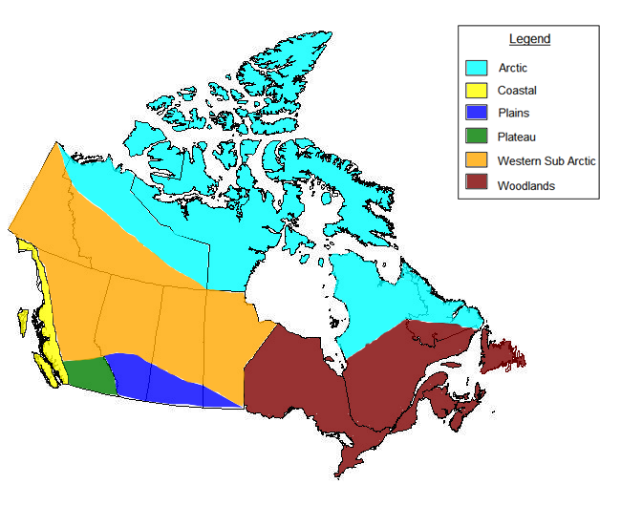
Identify 1-2 Individual Nations in each Region.

A

C

P

P

W

W

