Legend 1
This assignment is an extension from 1-2 (Home 2 School). We now look at mapping on a national scale and include 2 new concepts: grid and direction. Please include the following criteria below. You may design the legends differently and may add more information to each section.

Provinces/Territories, Capital Cities, Man Made or Natural Landmarks, Grid Location, Bonus
Province  Territory |  | Capital City |  | Landmarks |  | Landmark Location | Bonus Information
 | British Columbia | * | Victoria | 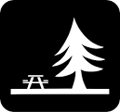 | Stanley Park |  | Stanley Park is a jewel in BC. It is approximately 1000 acres making it much bigger than Central Park in Manhattan. It is great for its wildlife, beaches, scenic drive, flowers, and much more. Approx. 8 million people per year visit it. This is 1/3 of Central Park visitors.
 | Alberta | * | Edmonton
Legend 2
Major Bodies of Water (4), Fresh Water Lakes (8 – include 5 Great Lakes)
Major Bodies of Water | Fresh Water Lakes
East – Atlantic Ocean | LS | Lake Superior

Legend 3
Mountain and Mountain Ranges (3)/Major Rivers (5)
Mountain /Mountain Range | Rivers
Rock Mountains |  | Mackenzie River - #1 (NWT & Yukon) | ________

Legend 4
Indigenous People of Canada (3) (First Nations-Aboriginal/Inuit/Metis)
Name | Area/Region | Information
Osoyoos Indian Band  Nk'Mip | Okanogan area – Osoyoos  Desert Region | Amazing band that went rom one of the poorest to one of the richest in all of Canada. Took on a business mentality.  Situated on 32,200 acres in one of Canada’s premier agricultural and tourism regions, the land has offered the band opportunities in agriculture, eco-tourism, commercial, industrial, and residential developments. With a focus on supportive education and training, the band operates its own business, health, social, educational and municipal services. The result is virtually no unemployment and financial independence. | 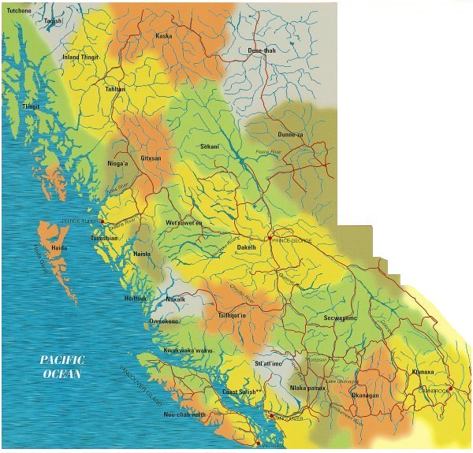
Legend 5
Incredible People/Individuals in Canada (Past or Present) Choose an area that fascinates you. Who are the leaders in that area? How did they impact others? What change did they create?
Name | Area/Region | Information
Jordan Tootoo | Inuit  Nunavut, Canada. | Tootoo is a Canadian National Hockey League (NHL) player, who has played for Nashville Predators and the Detroit Red Wings. He currently plays for the New Jersey Devils.  He is both the first Inuk player and the first player to grow up in Nunavut to play in an NHL game.
Terry Fox

- You may add any other information or categories you deem interesting or important to know: industries, language, etc.
- Laying the grid down will be done as a class activity: then you may record coordinates on your legends.

Recommended Steps:
- Research: Provinces, Territories, Capital Cities, Any Interesting facts you find could be added.
- Research Geographic natural features: Bodies of Water, Freshwater Lakes, Mountains and Rivers
- Research: Land marks (Man made or Natural) and possible facts on some in each Province and Territory.
- Research: Provinces, Territories, Capital Cities, Any Interesting facts you find could be added.
- Research Types of Indigenous groups in Canada. Read about them and pick 3 to expand upon them. Make sure to know and identify on the map where they are located.
- Pick 3 Canadians you admire or feel has impacted our country and explain why.
- Use the rough copy map to insert information.
- Decide on what symbols or images you will use to represent features.
- Carefully select patterns or colours to separate provinces: try to keep different shades of blue for the different waterways.
- Start on your good copy: make sure to add the 5 basic feature: border, scale…

