1-2 Understanding and Creating Logos

Important design elements on how ionic logos should be created:

- Describable
- Memorable
- Effective without colour – if use of colour - why
- Scalable i.e. work when just an inch in size
- Relevant to the industry in question

Points one and two go hand-in-hand — if you can’t describe what a logo looks like then how can you accurately remember it? Point three is important because colour is secondary to shape and form. I leave colour to near the end of the design process — if the mark doesn’t work in black only, no amount of colour will rescue the idea. Point four is vital for things like stationery and favicons — those brand items that tend to be smaller in size. Lastly, the design should be relevant for the business it identifies. This is accomplished through in-depth research into the industry in question, and helps to differentiate from closely-associated competitors.

1. Why are Logos Important: research and put into your own words

2. Can you identify one effective logo and one that is ineffective?

Effective | Ineffective
Why? | Why?
3. Can you identify these logos and tell me why they are effective?

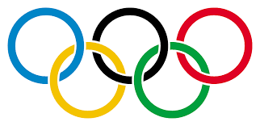 |  |  | 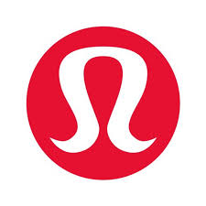
The Olympics
Each ring represents a continent. It was designed in 1912 by Baron Pierre de Coubertin, co-founder of the modern Olympic Games. The colours were selected as they represent every country’s flag that competed.

4. Can you create a logo in 3 different styles/formats?

Each of the following may be started by hand but the good copy must be done on computer. The challenge is to find a program that will allow you to create and manipulate graphics. Take a look on various letterheads before deciding which you like. This can be in your area of interest: service based, product based. Brainstorm ideas in class.

i. graphic only
ii. graphic with name
iii. graphic with name and colour

Extension: (bonus) put logo on a letter head with graphic and company contact

You should have a story behind what you design – metaphor, etc.
You may have to group your image together and then save it as a jpeg to keep the design consistent. Try using free aps such as WordSwag.

Bonus Challenge: Can you create a MRSS Golf Classic Logo – used for letterhead,
business cards, etc.

Assigned Date: September 18, 2017
Due Date: October 04, 2017

