Objective: This assignment is an opportunity to provide information about
yourself. You have the freedom to explore your interests and
share your ideas. Try to be descriptive and expand your initial
ideas.

Criteria The project will be a trifold consisting 6 panels.
The finished project should be sturdy as to sit independently on your desk. Since this is your first write of the year, the writing process (rough, drafts, editing, quality of design will be weighed heavier.)

Panels. 1. Slogan, Proverb, Poem, or Motto: something
you feel strongly about. In small font explain why it
is meaningful to you.
2. Name: large font so it can be seen at the back of the
class. Please include your last initial. Please add a
thumbnail picture of yourself in the corner.
3. Collage or Picture of your choice: can be done by
cut outs, computer, or neatly by hand.
4. Family & Friends: members, jobs, interests pets,
hobbles, etc.
5. About You: appearance, interests, hobbies, travel,
favourite books or movies, etc.
6. Goals: short term (3 months), medium term (2 years)
long term (5-10 years). What makes you happy?

Marking Criteria
Student Name: . Block: .
Writing Process: Rough Copy, 1st Draft – editing, 2nd draft – editing, Good Copy (Coloured Pens for editing/Thesaurus)
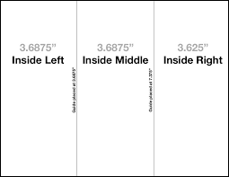
Process /10
Panel 1 – Quote __ /2.5
Panel 2 – Name /2.5 __
Panel 3 – Collage __ /2.5
Panel 4 – Family /Friends __ /05
Panel 5 – About Me _ /05
Panel 6 - Goals /2.5

