Teaching: LOVE
What is Culture?
- Definition: The social behaviour and norms found in human societies. Culture is considered a central concept in anthropology, encompassing a range of phenomena that are transmitted through social learning in human societies (Orgtology)
Purpose
Explore the diversity, uniqueness and similarities of indigenous cultures around the world.
Compare and contrast to First Peoples Culture (First Nations, Inuit, Metis).
Able to use technology skills (formatting, graphics design)) to enhance our communication.
Explore various programs (PowerPoint, Prezi, Word)
Steps
- Students may choose to focus on 1 indigenous group and focus on the cultural traits within that group, or
- Students may select multiple indigenous groups and select their favorite picture(s) for each trait.
- Each trait should have a minimum of 1 picture with the cation underneath, a minimum about one interesting fact about the picture, and a personal response.
- Tables can very. (Samples are below)

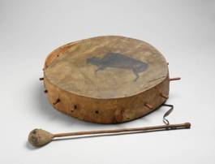

Art: Drum
First Nations-Plains
Drums are usually made from hide, wood, intestines (string) and are often used for ceremonial events.

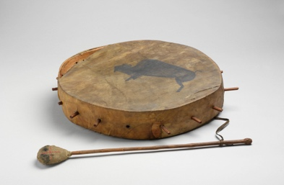

First Nations Drum - Plains
Drums are usually made from hide, wood, intestines (string) and are often used for ceremonial events.

One thing I would love to do is make my own drum and learn the process. Materials very, however common ones include wood, hide, string of some sort, etc.  Often there is a ceremonial if a drum is gifted or being completed. | 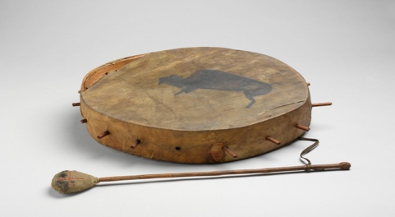
First Nations Drum - Plains

